Chapter 17, Problem 58.

Find the exponential Fourier series of a function which has the following trigonometric Fourier series coefficients

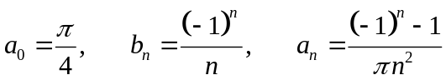

with T = 2π.

